PRACTICAL 1 & 2

1)

Program:
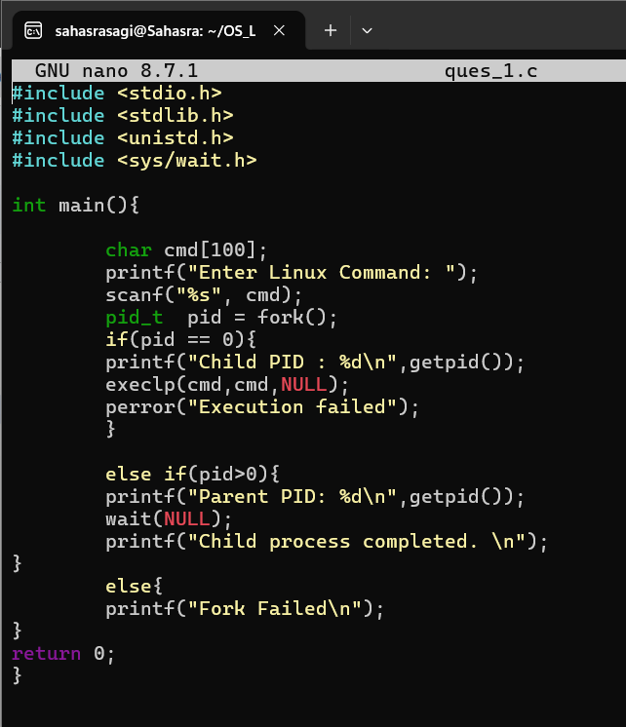

Output:
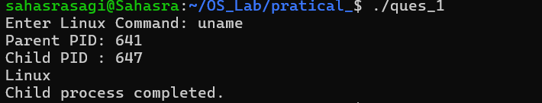
2)
Program:
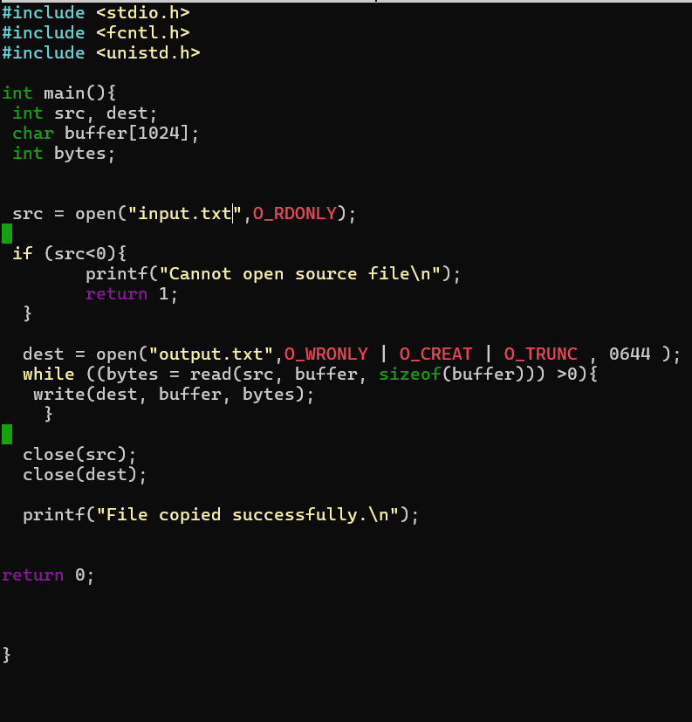

Output:

